HOME  
  
Md Mojahidul Islam  
I'm a passionate GRAPHIC DESIGNER  
  
  
  
About  
  
GRAPHIC DESIGNER  
  
Birthday: 17 March 1997

Website:

Phone: +880 1703 422 272

City: Rajshahi Bangladesh

Degree: Bachelor of Science in Engineering

* Mail: [mostakmojahid2@gmai.com](mailto:mostakmojahid2@gmai.com)  
  Freelance: Available  
    
  Skill   
  Adobe Illustrator  
  Adobe Photoshop  
  Adobe Premiere Pro  
  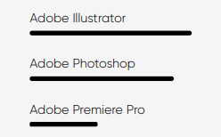  
    
    
  TESTIMONIALS  
    
  **Luis:** "He is such an amazing graphic designer he is so quick and creatvie so outstanding. So glad i have found you !!!!! The best i have ever worked with"  
   **erik_carmichael:** "Amazing work, super responsive and fast, you should not just look at what the freelancer total profit is ... very satisfied and strongly reccomend"  
    
  **Faizaiko:** "Again honestly looking forward for your graphic needs I went through many different graphic people and found a good solid person it here"  
    
  **Salicali:** Great communication and really accommodating. Thank you!  
    
  **chaonan:** Patient and quick to response to my revison requests, will buy again in the future.  
   **kendoy:** The seller was extremely prompt and completed the work exactly as I wanted. Will come back for sure.  
    
    
    
    
  Resume  
    
  পিডিএফ দেখা ও ডাউনলোড করা যায় এমন করা যাবে কি?  
  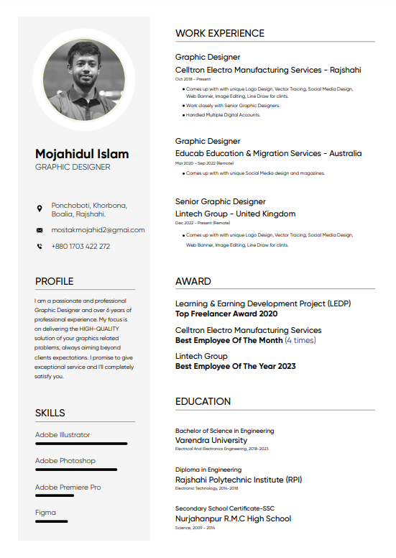  
    
  SERVICES  
    
  OFFER FOR YOU

[Logo](https://www.fiverr.com/categories/graphics-design/flyer-design?source=category_tree) Design  
Vector Tracing  
[Icon Design](https://www.fiverr.com/categories/graphics-design/icon-design?source=category_tree)  
[Brochure Design](https://www.fiverr.com/categories/graphics-design/brochure-design?source=category_tree)  
[Infographic Design](https://www.fiverr.com/categories/graphics-design/infographics-design?source=category_tree)  
[Social Posts & Banners](https://www.fiverr.com/categories/graphics-design/social-media-design/social-posts-banners?source=category_tree)  
[Web Banners](https://www.fiverr.com/categories/graphics-design/banner-ads?source=category_tree)  
[Packaging & Label Design](https://www.fiverr.com/categories/graphics-design/product-packaging-design?source=category_tree)

## PORTFOLIO

[Logo](https://www.fiverr.com/categories/graphics-design/flyer-design?source=category_tree) Design  
Vector Tracing  
[Icon Design](https://www.fiverr.com/categories/graphics-design/icon-design?source=category_tree)  
[Brochure Design](https://www.fiverr.com/categories/graphics-design/brochure-design?source=category_tree)  
[Infographic Design](https://www.fiverr.com/categories/graphics-design/infographics-design?source=category_tree)  
[Social Posts & Banners](https://www.fiverr.com/categories/graphics-design/social-media-design/social-posts-banners?source=category_tree)  
[Web Banners](https://www.fiverr.com/categories/graphics-design/banner-ads?source=category_tree)  
[Packaging & Label Design](https://www.fiverr.com/categories/graphics-design/product-packaging-design?source=category_tree)  
  
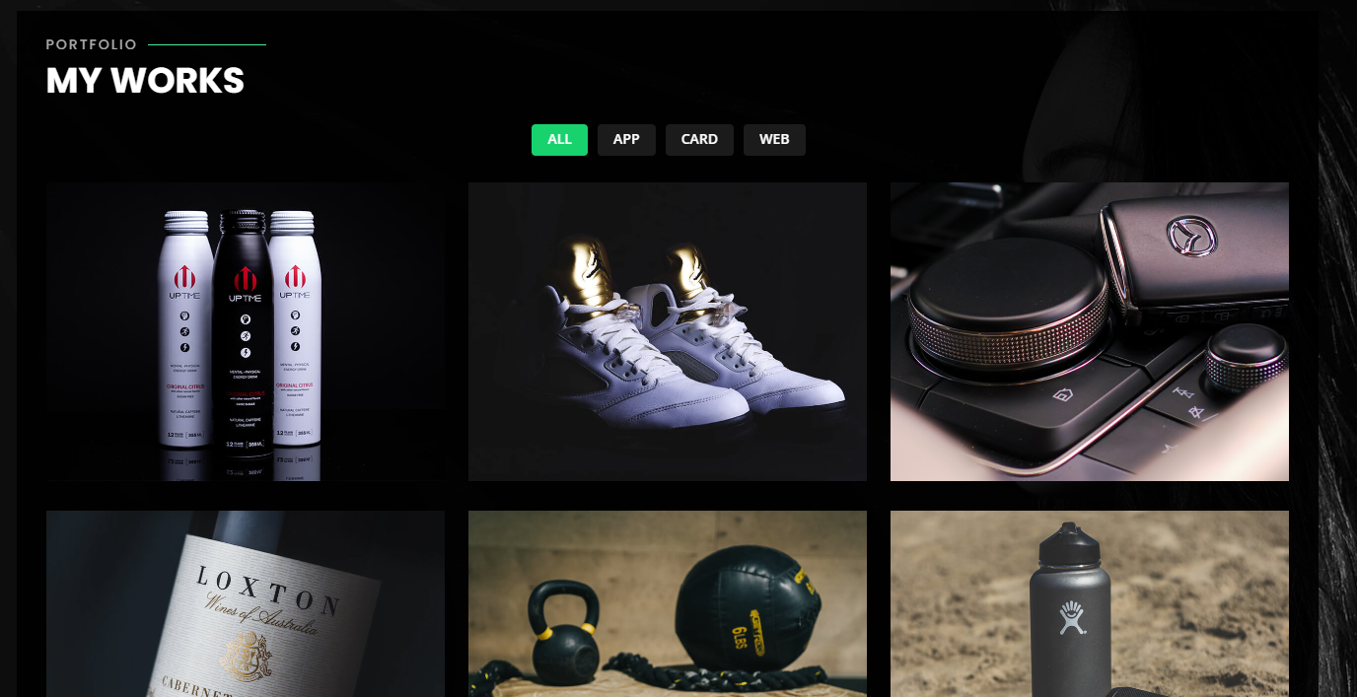  
LIKE THIS  
  
  
CONTACT

Mail: [mostakmojahid2@gmai.com](mailto:mostakmojahid2@gmai.com)  
WhatsApp : +880 1703 422 272  
  
<https://www.behance.net/mj_mojahid>  
<https://www.linkedin.com/in/md-mojahidul-islam-85186515b>  
<https://www.upwork.com/freelancers/~017e578717c3042dfc>  
<https://www.fiverr.com/users/mojahid88>